### Description

This plugin allows the admin to add automatic registrations for Catholic Engaged Encounter weekend retreats. It shows the locations and available weekend spaces. Visitors can register by filling the form on the site. Registrations are viewable through the "Catholic Engaged Encounter Management Community Portal".

### Version: 2.0.3

* Tested up to: 5.4
* License: GPLv2 or later
* License URI: http://www.gnu.org/licenses/gpl-2.0.html

### Changelog

* Prevention of duplicate registration by disabling the back button and adding a loader.
* Making paypal form editable inspecting the element with browser
* Copy button for shortcodes
* Validations enhancement for name and age fields
* Thank you page data handling
* Error handling with API.
* Another return page created on activation
* Custom message on activation of plugin
* Text along or in line with the shortcode is made fit with the editor.
* Documentations are added
* Menus are reduced from backend
* Summernote editor has been added
* Return page added for donation

### Installation

1. Upload the entire Catholic_Engaged_Encounter_Registrations folder to the /wp-content/plugins/ directory.
2. Activate the plugin through the Plugins screen (Plugins > Installed Plugins).

You will find CEE menu in your WordPress admin screen.

### [Community_Schedules]

You can get all the schedule lists and their corresponding information according to location where someone can register and pay their fee using paypal payment method.

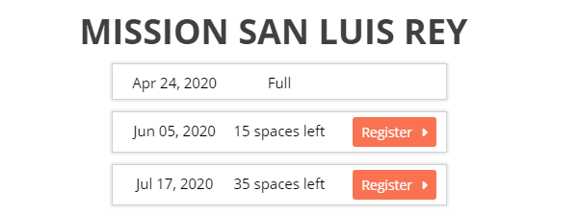

### [Schedule_Chronological]

This shortcode helps you get all the schedule lists chronologically where someone can register and make the payment using paypal payment method.

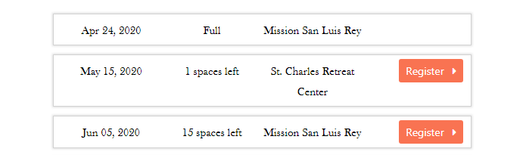

### [Scholarship_Shortcode]

Using this shortcode, you can get all the schedule lists where someone can register for a scholarship. Remember, no payment is required for this option.

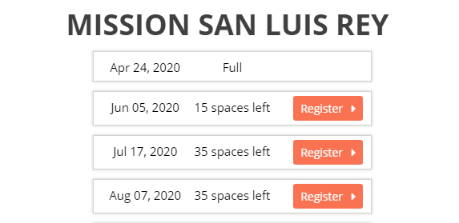

### [Community_Locations]

This is for getting all the locations. You can get all the information about the locations as well as their location in google map.

### [Add_Donation]

Admin can accept donations through this shortcode through paypal donations facility where donors can choose if they make it monthly donation.

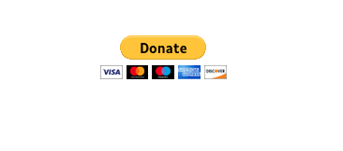

### More Information

* The plugin provides capability to add contents before and after of shortcodes from CEE menu in wordPress dashboard.
* The plugin creates two pages on activation of the plugin where the pages are being deleted at the thime of deactivation. The pages are:
  1. Thank You For Registering
  2. The page is a return page of paypal payment. Users register to a schedule providing their information through the system and pay a specific amount for the schedule. After successfully payment for a schedule, payers are returned to this page and can see their informations as shown in following image.

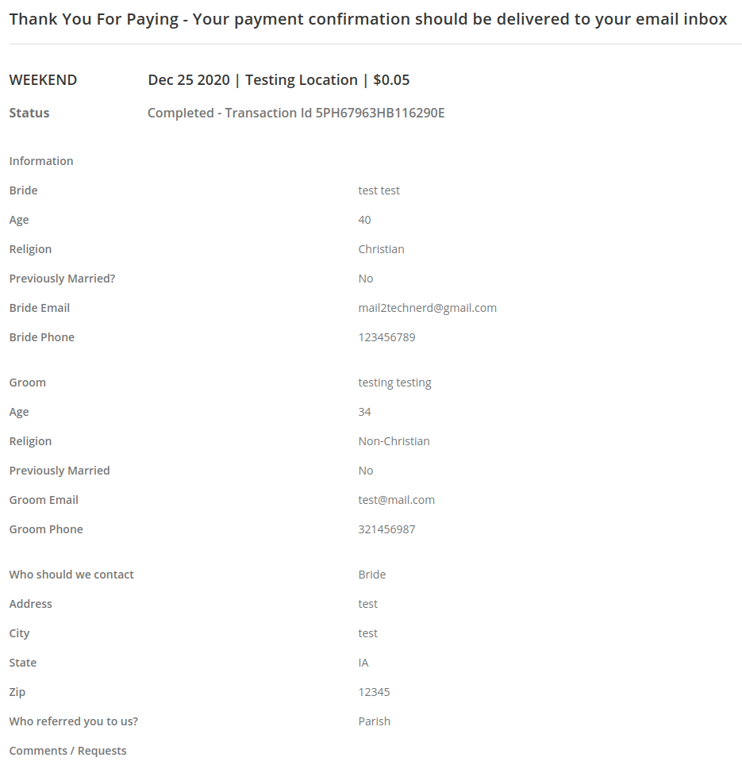  
Thank You For Donation

* As donors donate to a community, after donation completetion donors are returned to this page and showed a message as follows
* 